[Ecosystem Simulator]
Use Case Model

Date | [November 22, 2014]
Version | [1.0]
Status | [Draft]
Author | [Nguyen Van Chuc An, PM]
Reviewed by
Approved by

Revision History
Date | Version | Description | Author
<November 22, 2014> | <1.0> | <Describe use case model> | <Nguyen Van Chuc An>

Table of Contents
1 Introduction 4
1.1 Purpose 4
1.2 Scope 4
1.3 Definitions, Acronyms and Abbreviations 4
1.4 References 4
1.5 Overview 4
2 Use Case Model 5
2.1 List of usecase 5
2.2 Actors 5
3 Pakage description 6
3.1 Primary Use Cases pakage 6
3.1.1 Change simulator at runtime 7
3.1.2 Change concrete particular species at runtime 7
3.1.3 Add a new ecosystem 8
3.1.4 Add a new creature 8

Introduction

Purpose

<Define purpose of project and purpose of document>

Design an ecosystem simulator that enables to set up different environments (ecosystems) containing animals and plants that move around and interact with each others.

This is document describes use case model of Ecosystem Simulator.

Scope

<Provide a short description of the software being specified and its purpose, including relevant benefits, objectives, and goals. Relate the software to corporate goals or business strategies. If a separate vision and scope document is available, refer to it rather than duplicating its contents here. An SRS that specifies the next release of an evolving product should contain its own scope statement as a subset of the long-term strategic product vision.>

This is document describes the Use case scenario of ES.

This document is used by development team.

Definitions, Acronyms and Abbreviations

No | Term | Description
1 | PM | Project Manager
2 | ES | Ecosystem Simulator

References

<List any other documents or Web addresses to which this SRS refers. These may include user interface style guides, contracts, standards, system requirements specifications, use case documents, or a vision and scope document. Provide enough information so that the reader could access a copy of each reference, including title, author, version number, date, and source or location.>

Overview

Use Case Model

Use Case Model

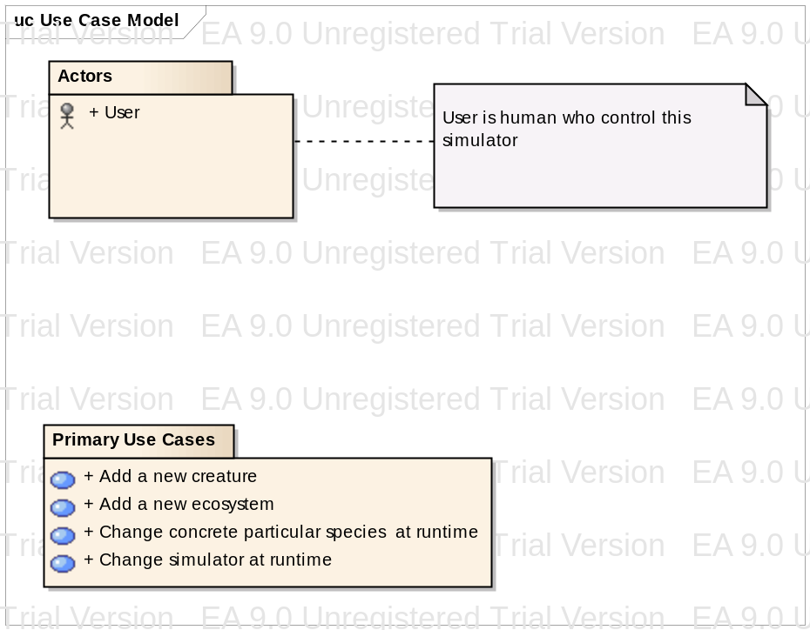
Figure 1 Use Case Model

List of usecase

Usecase Name | Usecase Code
Change simulator at runtime | UC_01_ChangeSim
Change concrete particular species at runtime | UC_02_ChangeCon
Add a new ecosystem | UC_03_AddEco
Add a new creature | UC_04_AddCre

Actors

List of Actors

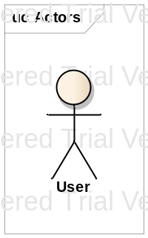
Figure 2: Actors

User
user is human who control this simulator

Pakage description

Primary Use Cases pakage

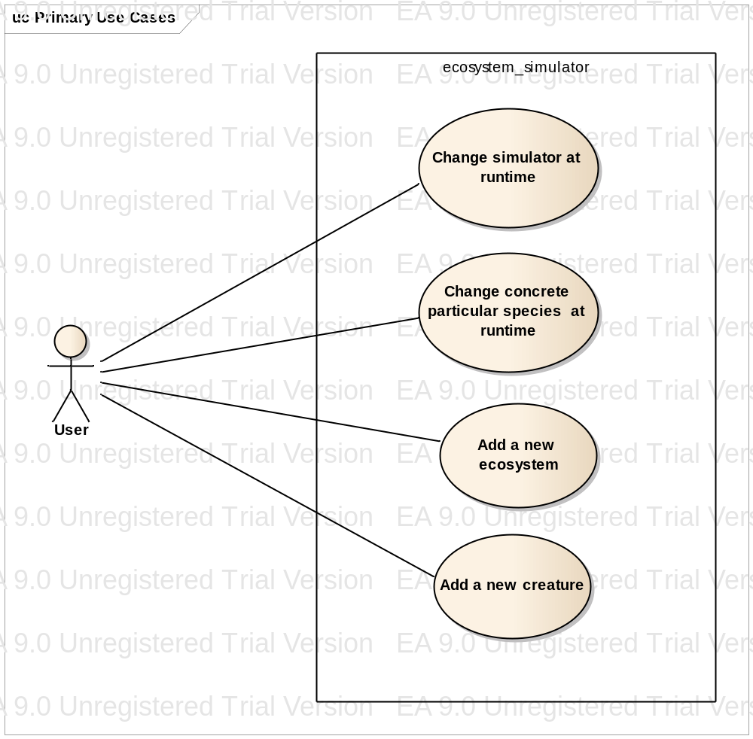
Figure 3: Primary Use Cases

- Change simulator at runtime

Use case name: Change simulator at runtime
Use case code: UC_01_ChangeSim
Actor:

User

Brief description:

This Use describe change an environment at runtime. Ex: Africa to Finnish

Flow of events:

This use case started when user want change environment at runtime
- User select option change simulator
- System change simulator associated with use’s chosen
Pre condition:

User want to change environment

Post condition:

Context, creatures will be changed

Alternative flow of events

- Change concrete particular species at runtime

Use case name: Change concrete particular species at runtime
Use cae code: UC_02_ChangeCon
Actor:

User

Brief description:

This Use describe change creatures at runtime. Ex: Lion to Leopard

Flow of events:

This use case started when user want change creatures at runtime

- User select option change concrete
- System change concrete associated with use’s chosen

Pre condition:

User want to change concreate creatures

Post condition:

creatures will be changed only

Alternative flow of events

- Add a new ecosystem

Use case name: Add a new ecosystem

Use cae code: UC_03_AddEco
Actor:

User

Brief description:

This Use describe add an environment at runtime. Ex: High mountain

Flow of events:

This use case started when user want add environment at runtime
  - User select check box add
  - System add simulator associated with use’s chosen

Pre condition:

User want to add environment
Check box add new creature must be not selected

Post condition:

Context, creatures will be changed at high mountain only

Alternative flow of events

- Add a new creature

Use case name: Add a new creature
Use cae code: UC_04_AddCre
Actor:

User

Brief description:

This Use describe add an createture at runtime. Ex: mushroom

Flow of events:

This use case started when user want add an createture at runtime

  - User select check box add
  - System add creature associated with use’s chosen

Pre condition:

User want to add creature
Check box add high mountain must be selected

Post condition:

creatures will be added
att creature at high mountain only

Alternative flow of events

